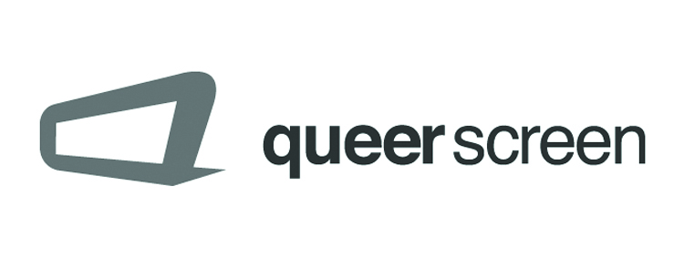 | Mardi Gras Film Festival 2017  MY QUEER CAREER  Queer Screen celebrates 24 years  February - March 2017, Sydney, Australia

Presented by Queer Screen as part of the Mardi Gras Film Festival, My Queer Career aims to showcase the best in Australian short filmmaking of interest to, or created by Queer (LGBTIQ) identified screen practitioners. Sponsored by the Stephen Cummins Film Trust – the Best Film award carries a $3000 cash prize, alongside prizes in many other categories! In 2017, Queer Screen celebrates 24 years of being Australia’s leading Queer Screen / Arts organisation and we are searching for the finest Australian short films to be part of this year Mardi Gras Film Festival.
Entries can be submitted on DVD, USB or through an online link to download or streaming.
Please include the following supporting material with your submission digitally (.doc & PDF):
Synopsis Directors Bio Stills (Hi Res) Press Kit List of Credits

Closing date for entries is Monday 14 November 2016, 5pm

Send submissions to 1) Queer Screen, P O Box 1081, Darlinghurst, NSW 1300, Australia (mailing address)
one of the following: 2) Queer Screen, Suite 313/ 410 Elizabeth St, Surry Hills, NSW 2010, Australia (street address, for couriers)
3) As digital links / files programming@queerscreen.org.au
Please mark the package: Preview tape only / No commercial value / For film festival purposes

Title: |  | Year of Completion:
Director: |  | Duration:
Producer/Rights Holder: |  | Country of Origin: Australia only
Australian premiere: Yes or No |  | Key (3) screenings / premiere in last 6 months: Yes or No
Email contact: |  | Website:
Category: Fiction - Documentary - Animation - Experimental
Exhibition Format: DCP - ProRes File - H264 File
Screen Ratio : | Original language: |  | English Subtitles: Yes or No

Short synopsis:

Principal contact: | Position:
Full Address: | Phone: | Fax:
Email contact: | Website/URL:

I certify that I hold all necessary rights for submission of this film/video to the Mardi Gras Film Festival, and if selected, grant permission to Queer Screen to reproduce part of the film to include as part of a compilation or collection and to exhibit the film by any means, including theatrical screening, internet, cable, satellite, microwave or by any medium not yet devised, for promotional purposes.

Signature: | Name: | Date:

Regulations and conditions of entry to the Mardi Gras Film Festival 2017
1. Industrial, promotional and instructional films are ineligible. 3. It is Queer Screen's policy not to offer comments or reasons when submissions are not invited to participate. 4. Once a film has been submitted, it cannot be withdrawn. 5. Queer Screen accepts no responsibility for loss or damage to preview tapes and any supporting material. 6. Queer Screen, its officers, agents and employees take no responsibility for any infringement of copyright, performers' rights, defamatory, illegal or obscene material or other liability whatsoever contained in or arising out of films/videos submitted. 7. Submission of a film represents agreement with the terms and conditions set out herein. There is no entry fee for submissions.

