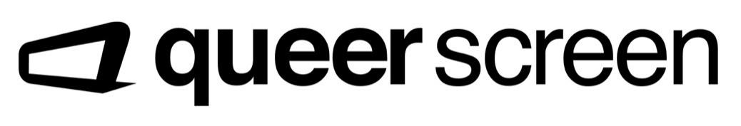
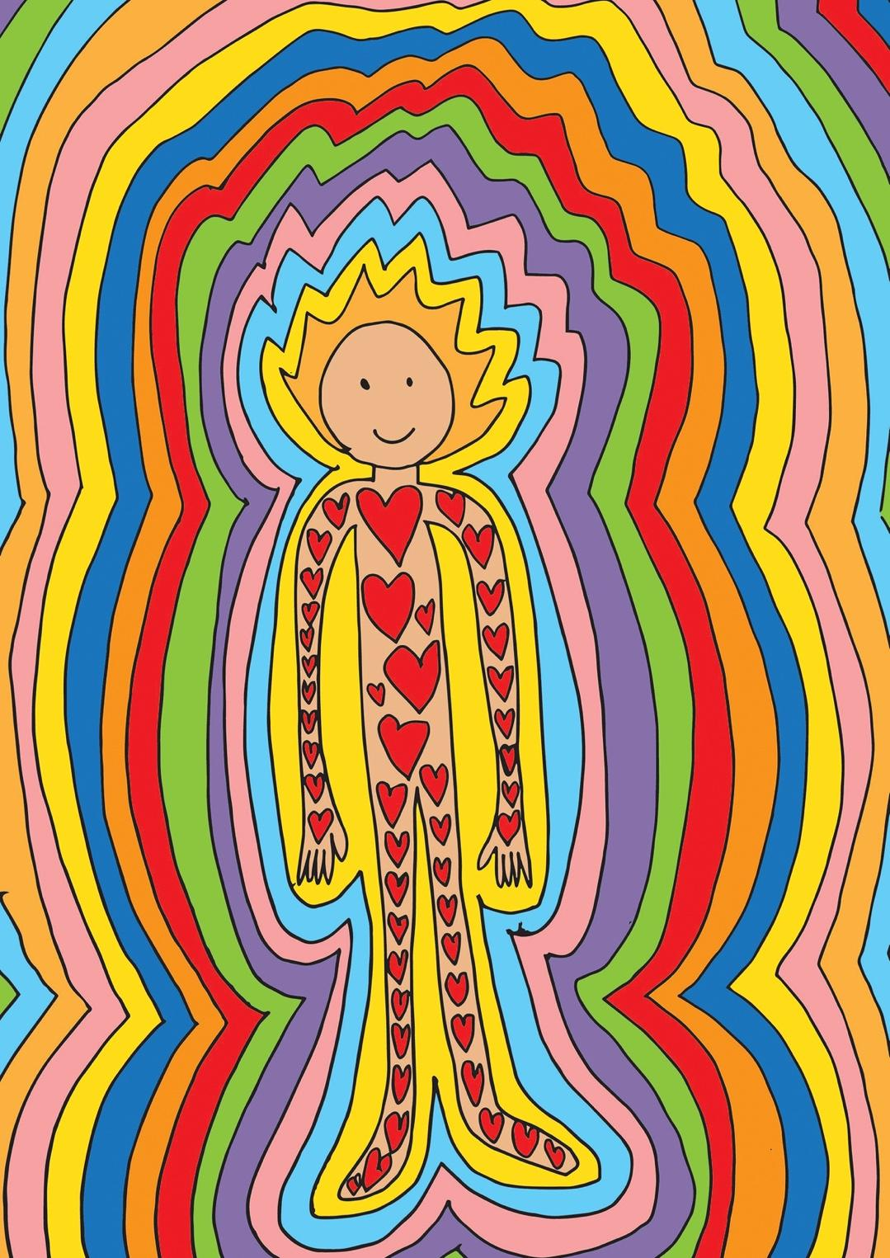
Disability Inclusion Action Plan (DIAP)
2022–2024
Cover artwork Protected and Accepted by my Queer Community
by Nina Hurr
Artist statement
This artwork is all about feeling included and safe. Our queer community looks out for each other and helps each other when we’re going through hard times. Everyone is included and accepted. When I’m having trouble with my mental health I feel supported and protected. The rainbow colours around the person represent this feeling of safety and protection. It is a rainbow inclusive shield that encourages creativity and fun. The love hearts on the person’s body remind us to love our body however it looks, even if it is different, unique, or not how we’d like it to look. It celebrates queer pride and diversity, both physically and mentally.

Acknowledgement of country
Queer Screen feels honoured to work, create and contribute to the community on the land of Australia’s traditional custodians. We acknowledge their wisdom and resilience in the face of injustices. We pay our respect to their Elders past and present and extend that respect to all Aboriginal and Torres Strait Islander peoples.
Other acknowledgements
Queer Screen would like to acknowledge those people who contributed their time and expertise to participate in the development of this plan, including:
- Our survey respondents
- Our focus group participants
- Our filmmakers, staff, contractors, volunteers and Board
- Our audience members, community partners and other stakeholders
- Accessible Arts
Alternative formats
Our DIAP is available in alternative formats, including accessible PDF, accessible Word and EPUB (all available on our website, queerscreen.org.au). Hardcopy formats (in both large and standard print) and other alternative formats are also available upon request.
A note on language
We recognise that there are varying views on language and terminology around disability in Australia and internationally. Language can be a personal, and also political, choice. We use the person-first language of “person with disability” to recognise that disability is just one aspect of a person’s life and does not determine who they are. However, we respect that different people have different preferences about language.

Contents
Artist statement 2
Acknowledgement of country 3
Other acknowledgements 3
Alternative formats 3
A note on language 3
Message from the Queer Screen Board of Directors 5
Introduction 6
Who we are 7
Disability in Australia 8
Intersectionality 9
Disability and LGBTQIA+ communities 10
Our DIAP 11
Our achievements to date 12
Methodology and consultation 14
Governance, monitoring and review 14
Plan commitment, vision and goals 15
Our actions 16
DIAP 2022–2024 Action List – Part 2 of the Plan 16
Outcomes, Areas, Actions and Measures 16
Contact us 33

Message from the Queer Screen Board of Directors
Queer Screen is delighted to present its Disability Inclusion Action Plan (DIAP). In 2021, the Queer Screen Board passed a motion to create and maintain a Queer Screen DIAP. With the support of Accessible Arts and the Queer Screen team we have landed on a sustainable plan we are committed to delivering.
This DIAP has been produced in collaboration with people with disability and we acknowledge the presence and contributions of people with disability to this Plan and at Queer Screen events, including among our audiences, our filmmakers, our My Queer Career alumni, our volunteers, and our Board.
We received overwhelming positive feedback during COVID about our streaming options opening up the opportunity for many more people to participate in our events.
We invite our community to get in touch at any time with feedback as we continue on our journey to further develop and improve access and inclusion at our festivals.
At Queer Screen we celebrate the diverse voices of our community. Community storytelling has always been and will continue to be the key driver of our work at Queer Screen. We strive to ensure our whole community is represented.
While we are only a small organisation, we are a strong community organisation, and we have had some significant achievements around accessibility over the last few years, including providing Auslan, open captioning and audio description for some of our films, a focused disability programming strand, “Queerability”, and screening films which include actors with disability.
The Queer Screen Board is committed to continuing to develop and review the DIAP.
By going through the process of producing this DIAP, we now have a roadmap for how we will continue to strategically make improvements to access and inclusion over the next few years. We are committed to continuous learning as an organisation, and we will continue to explore new avenues and possibilities in this area – and most importantly, be open to ongoing feedback from our community.
Queer Screen Board of Directors

Introduction
Queer Screen exists to serve our community. Inclusion is important to us, because that’s what a community approach requires – to ensure we are considering the needs of all members of our community. We see access as a key component to facilitating this. This includes working to remove structural barriers that can prevent people from participating in our events, as well as addressing financial, social and geographic barriers to access.
Our Disability Inclusion Action Plan (“the Plan”, or DIAP) highlights our access work to date and outlines our approach for further improving accessibility and inclusion for people with disability across all aspects of our events.
The Plan reinforces and focuses our work to ensure we include and represent people with disability – as filmmakers, artists, audiences, staff, contractors, partners, donors, members, and other stakeholders. We want the whole of the community to feel welcome at our events and we want our work to represent all aspects of our multifaceted community.
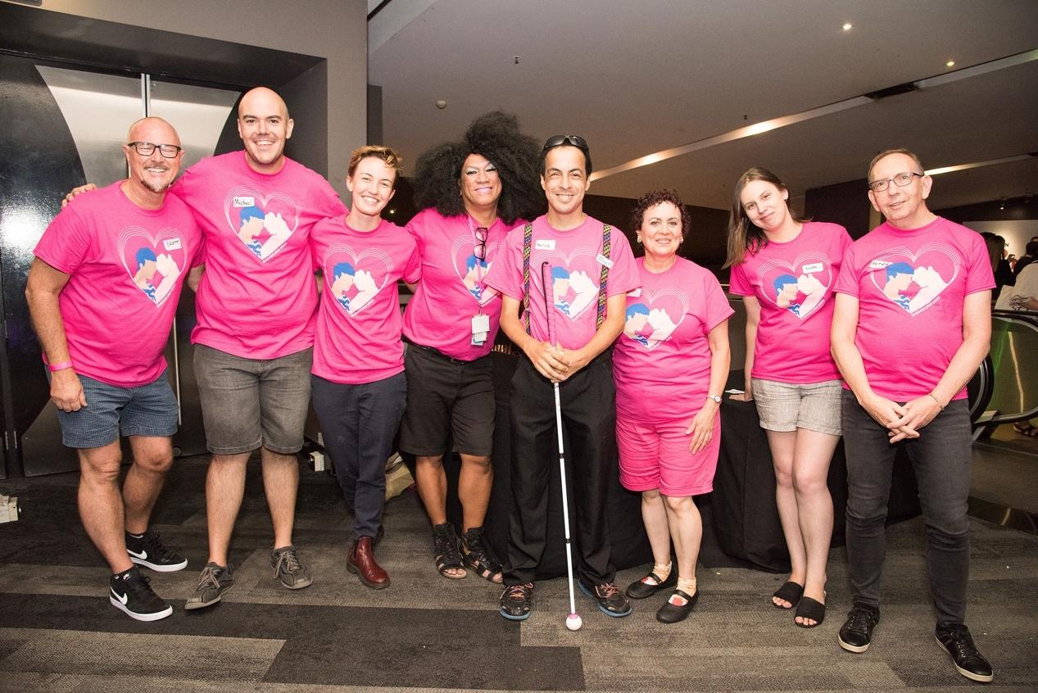
Queer Screen volunteers at Mardi Gras Film Festival 2020 Opening Night film Ellie and Abbie (and Ellie’s Dead Aunt)

Who we are
Our vision is to produce a celebration of the diversity of sexualities and gender identities through queer storytelling on screen, by inclusive and respectful communities full of creativity, inspiration and pride.
Our mission is to transform and engage individuals and communities through queer storytelling on screen.
In 2023, Queer Screen will celebrate our 30th year of operations, coinciding with Sydney’s World Pride celebrations.
Established in 1993 by a group of queer Sydney filmmakers, students, and supporters, Queer Screen set out to reclaim Sydney’s LGBTQIA+ film festival as a community owned and operated event, and to champion queer film and screen culture.
Queer Screen’s Mardi Gras Film Festival (MGFF) has grown considerably since 1993. It is now not only one of the largest film festivals of any kind in Australia, but one of the top queer film festivals in the world. The MGFF is highly regarded by filmmakers around the globe, and is the most important platform for promoting LGBTQIA+ titles to distributors and exhibitors in our region.
Since 2013, our Spring film festival, the Queer Screen Film Fest, has also become a major annual event delivering the latest LGBTQIA+ movies to Sydney’s screens in the month of September. With the introduction of on-demand screenings in 2020, Queer Screen has established a national program of events throughout the year. Queer Screen has also supported filmmakers with funding initiatives such as the Completion Fund and Pitch Off competition.

Disability in Australia
The 2006 UN Convention on the Rights of Persons with Disabilities defines people with disability as those “who have long-term physical, mental, intellectual or sensory impairments which in interaction with various barriers may hinder their full and effective participation in society on an equal basis with others”.
Queer Screen follows the social model of disability that distinctively signals the difference between a person’s individual condition or impairment, and the barriers they experience which are created by the environment and society around them. Instead of the condition, it is the “barriers” which are disabling, as these limit opportunity, autonomy and self-expression, and create disadvantage.
Disability can be both permanent or temporary and invisible or visible. We include mental health within our definition of disability, as well as members of the d/Deaf community (who may not choose to identify as people with disability, but instead as part of a cultural and linguistic minority, with their first language being Auslan). We recognise that not everyone who faces these barriers chooses to identify as a person with disability and we understand that identity and disclosure in the context of disability is complex and very personal. We also understand the principles of universal design, that one size does not fit all, and the complexities of intersectionality within disability.
Disability impacts us all. It is a very broad diversity group and is very commonly experienced amongst our community – with people either directly identifying themselves, being a carer for someone else, or having a family member or close friend with disability. The statistics shared below demonstrate how widespread disability is:
- One in five Australians are people with disability (17.7% or 4.4 million people).
- Of the 7.80 million residents of NSW, 1.37 million (18.34%) have disability.
- People with disability from non-English speaking backgrounds face multiple layers of disadvantage and make lower than average use of disability services because they may not be aware of what is available and the services may be culturally inappropriate.
- Just under half (45.1%) of Aboriginal and Torres Strait Islander people aged 15 years and over experience disability.
- People with disability are twice as likely to be in the bottom 20% of gross household incomes.
- 45% of those with disability in Australia are living either near or below the poverty line, more than double the OECD average of 22%.
- 45% of the population will experience a mental health condition at some point in their lives.
- Almost half of Australians (47% or more than 11 million people) have one or more chronic conditions.
- Vision 2020 Australia estimates there are currently over 575,000 people in Australia who are blind or vision-impaired.
- One in six Australians are impacted by hearing loss. There are approximately 30,000 Deaf Auslan users with total hearing loss.
Intersectionality
We understand that the barriers people with disability experience can compound and layer when an individual is part of more than one under-represented group. Recognising that people’s lives are multidimensional and complex, we aim to take an intersectional approach in our thinking around accessibility, which means focusing on the points of intersection that multiple identities create. Intersectionality recognises the diversity of experiences within marginalised groups and provides a framework for recognising and addressing the needs of individuals who are most disadvantaged, setting a pathway for a more just and equitable world.
We are mindful of these intersections and aim to provide good access for people with disability from all backgrounds and lived experiences. This includes members of the LGBTQIA+ community, First Nations people, women and non-binary people, culturally and linguistically diverse people, people from regional and remote areas, older people, children and young people, and people from lower socio-economic backgrounds.
Disability and LGBTQIA+ communities
Around 18% of people in the entire population of Australia are living with disability. Rates of disability among the LGBTQIA+ community specifically are much higher with:
- 39% of LGBTQIA+ people aged 14 to 21 identifying as having disability or a long-term health condition
- 27% of people with an intersex variation aged 16 and over identifying as having one or more impairments or conditions
- 36% of transgender people aged 18 and over identifying as having a mental health issue that they described as being disabling or a chronic health condition.
Unfortunately, belonging to the LGBTQIA+ community as a person with disability can be more challenging. Research among a sample of people belonging to both disability and LGBTQIA+ communities has shown that people with a severe to moderate disability are less likely to agree that they feel part of the LGBTQIA+ community, than those without disability or with a mild disability.
People with a severe disability were more than three times less likely to report feeling accepted at LGBTQIA+ events and venues. LGBTQIA+ community members with disability reported higher levels of psychological distress, suicidal ideation and suicide attempts, and lower self-rated health than those without disability. This data shows that LGBTQIA+ people with disability experience a range of additional challenges that require supportive intervention.
Historical oppression and social inequalities influence the experiences of both LGBTQIA+ people and people with disability. For LGBTQIA+ people with disability, experiences of discrimination and oppression are compounded by multiple social identities. Having multiple, intersecting identities means LGBTQIA+ people may have to either mask or closet identities or “come out” many times, in different ways, in many different contexts, and this can be a lifelong process. We recognise there are significant issues affecting the lived experiences of LGBTQIA+ people with disability that result in weighty consequences of exclusion and discrimination.
Our DIAP
Queer Screen’s purpose is to provide a platform for queer storytelling on screen and contribute to an inclusive and respectful community full of creativity, inspiration and pride.
And this means that our events must represent and include everyone.
To ensure we are more inclusive in everything we do and that everyone has access to queer stories on the big screen, this Plan is our practical and implementable roadmap that will hold us accountable to ensure we make positive change. It outlines our strategy to embed access and inclusion principles across all aspects of our work and builds upon the steps we’ve already taken over the past few years. Our DIAP is a key component of our organisational planning and will shape how we engage with audiences, filmmakers, staff, Board, members, volunteers and other stakeholders into the future.
This Plan is written at a particular moment in time and sets out our approach and the actions that we can achieve over the next few years. While we have identified many focus areas and opportunities for improvement, we want to ensure this Plan is a living and breathing document, so it may be adapted and updated over the course of its life to best reflect current community needs. We are committed to continuous improvement and working closely with people with disability inside and outside our organisation to identify barriers and find solutions. We acknowledge that access and inclusion is an ongoing journey, not a destination.
We look forward to realising the objectives, goals and actions outlined in our DIAP. We value the community’s ideas and feedback on our progress and encourage you to share your thoughts and experiences with us.
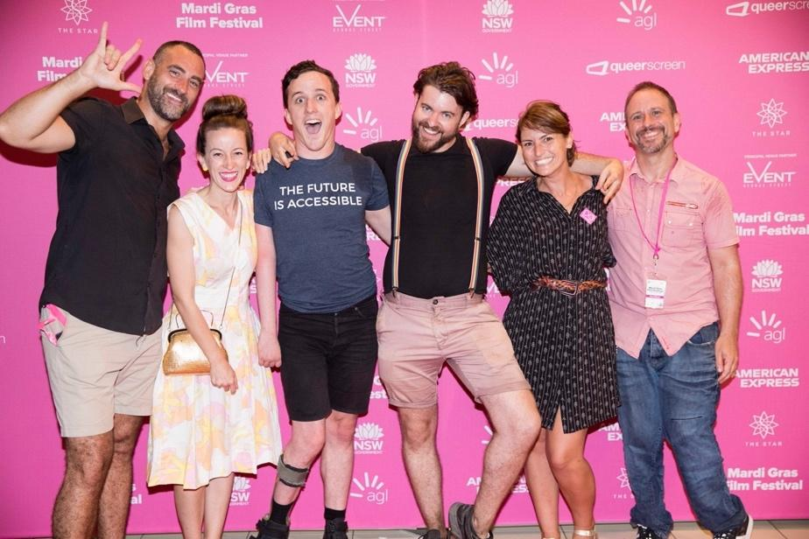
Actor and screenwriter Daniel Monks (third from left) at the open-captioned, Auslan-interpreted screening of his feature film Pulse (MGFF2018)
Our achievements to date
We have been making improvements to access and inclusion over the last few years.
Our recent achievements include:
- Selection of free films at Queer Screen Film Fest 2017, including The Lavender Scare which was completely Auslan-interpreted live in cinema.
- Focus on disability at Mardi Gras Film Festival 2018 with the program strand “Queerability”.
- Screened feature film Pulse (open-caption screening) with Daniel Monks (writer, star) present for an Auslan-interpreted Q&A, as well as screening of the documentary feature Stumped and the Queerability Shorts package (open-caption screening).
- Open-caption screening with audio description of feature films I Used to Be Normal: A Boyband Fangirl Story at Queer Screen Film Fest 2018 and Sweetheart at Mardi Gras Film Festival 2022.
- The number of films with open captions screened at our festivals has steadily increased since 2018. We now offer a selection of open-captioned screenings at all festivals, both in cinema and on demand.
- Screening of Australian feature film Unsound (which featured a Deaf main character) with open captions and Auslan interpretation, and the US feature film Season of Love (which featured a Deaf supporting character) with open captions and Auslan interpretation at Mardi Gras Film Festival 2020. Both screenings were followed by Q&As with cast and crew.
- Have partnered on screenings with organisations such as Advance Diversity Services, Deaf Rainbow NSW, Dementia Australia.
- Introduction of complimentary Financial Aid tickets to those facing social or economic barriers to attending Queer Screen events.
- Have undertaken community outreach to groups such as Life Without Barriers, People with Disability Australia, SQuAD and ACON to offer Financial Aid tickets and other free tickets to their community.
- Auslan interpretation at films with festival guests when films are presented with open captions or are subtitled.
- Spoken introduction points (acknowledgement of country, partner thanks, important information pertaining to the screening e.g. content warnings) are included in on-screen captioning for all films with open captions.
- Since 2020, we have continued on-demand offerings of feature films, documentaries and shorts packages with a large selection of titles offered with closed captions and subtitles.
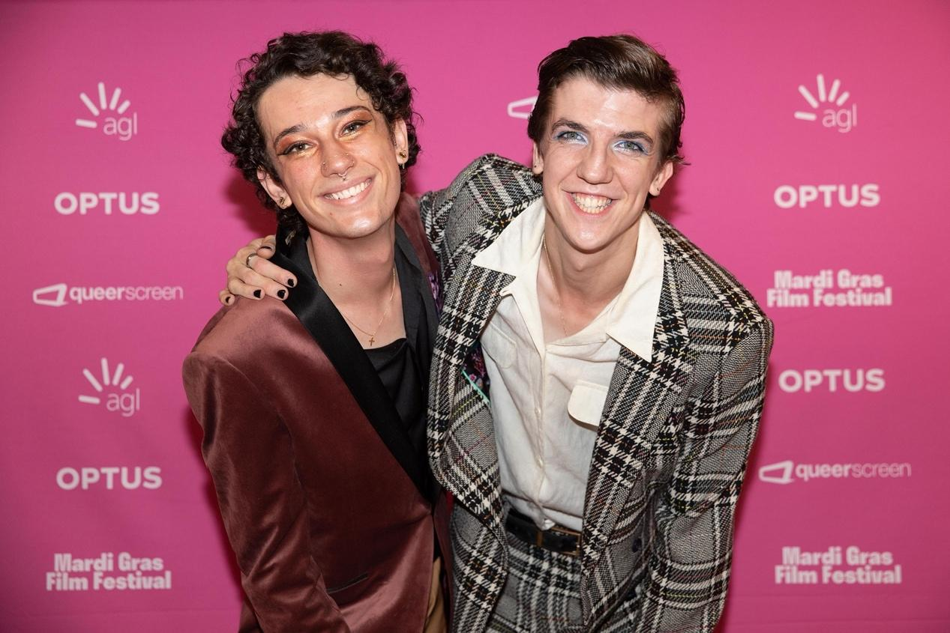
Benaiah Brophey (left) and Jeremy Lowrencev (cast, right) at the 2022 “My Queer Career” screening of Illustrating Sam Newton which features a Deaf main character

Methodology and consultation
To develop this Plan, we partnered with arts and disability peak body Accessible Arts and engaged with a diverse mix of stakeholders with disability and from the LGBTQIA+ community to seek feedback and ideas.
Accessible Arts has led the consultation phase of this Plan’s development, which has included:
- Presentations and discussions with staff and Board
- A series of interviews with staff, contractors and volunteers
- An internal survey sent to staff, Board, contractors and volunteers
- An external survey sent to the entire Queer Screen community
- Two Focus Group discussions, one with external stakeholders with disability and another with the Board
- A WCAG 2.1 website compliance audit
- An Access “Walk and Talk” conducted at the Event Cinema complex (the main venue used by Queer Screen).
The types of consultation processes used throughout the development of this Plan will continue throughout its implementation and beyond, to ensure we are receiving feedback directly from people with lived experience to inform our thinking and design of our future work.
Governance, monitoring and review
We are committed to continuous improvement and are keen to draw on ongoing community feedback and work in partnership with relevant organisations to ensure we meet our goals.
To support the implementation of this Plan, we will form a paid external Disability Advisory Group to provide strategic advice, lived experience and feedback to inform our actions.
The Disability Advisory Group will meet at least twice per year to monitor and review Plan progress, with reports on progress made to the Board.
We may also engage other experts, partners and stakeholders with lived experience of disability to assist us with Plan implementation or specific events as required.
Feedback from the Disability Advisory Group, staff, filmmakers and audiences with disability, as well as arts and disability organisations, will be gathered over the life of the DIAP, to contribute to the Plan’s evaluation and ensure that continuous improvement is made.
We will provide an external report on the Plan’s progress annually, published on our website, and distributed by the organisations eNews.
Plan commitment, vision and goals
We are committed to increasing disability confidence and competence within our organisation and are working to create an environment where we can provide opportunities for everyone on an equal basis.
We want to:
- Create a welcoming and inclusive environment for all members of our community at online and in cinema events
- Model and advocate for inclusivity across the screen sector
- Create opportunities for people with disability to volunteer and work with Queer Screen
- Provide opportunities for queer filmmakers and people with disability to tell their stories
- Involve people with disability in our discussion and decision-making about accessibility
- Be open to feedback and be held accountable to making positive change.
To do this, we have set ourselves the following goals to achieve over the next three years:
- Queer Screen will demonstrate positive attitudes and behaviours, enabling people with disability to engage and participate in our events as audiences, artists, staff and volunteers.
- Queer Screen will strive to meet the needs of its diverse range of audiences, artists and other stakeholders in all its activities.
- Queer Screen values diversity and will commit to increasing the inclusivity and accessibility for its staff and volunteers.
- Queer Screen will aim to continuously improve the inclusivity of systems and processes, to promote greater accessibility for our community.
Our Plan follows the NSW Disability Inclusion Action Planning Guidelines, with the following outcome areas, to which our goals closely relate:
- Attitudes and Behaviours
- Accessible and Liveable Communities
- Employment
- Systems and Processes
Each of these areas seeks to remove or reduce the social, economic, physical and behavioural barriers that prevent people with disability fully engaging in society and engaging with Queer Screen.
This Plan aligns with international, national and NSW social policy and legislative frameworks including:
- UN Convention on the Rights of Persons with Disabilities 2006 (UNCRPD)
- Disability Discrimination Act 1992 (DDA)
- Disability (Access to Premises – Buildings) Standards 2010
- National Disability Strategy 2010–2020 (NDS)
- National Arts and Disability Strategy 2009
- Disability Inclusion Act NSW 2014.
Our actions
Our commitment, vision and goals will be realised through a series of actions we will be taking over the next three years. These are outlined in the Action Plan below.
DIAP 2022–2024 Action List – Part 2 of the Plan
Four key outcome areas of the Disability Inclusion and Action Plan
This plan groups its actions under four key outcome areas. They are:
- Attitudes and Behaviours
- Accessible and Liveable Communities
- Employment
- Systems and Processes
Outcomes, Areas, Actions and Measures
Key outcome area 1 – Attitudes and behaviours
The attitudes and behaviours of the general community towards people with disability have been described as the single greatest barrier to full access and inclusion. Attitudes and behaviour permeate all aspects of life. Low expectations and negative attitudes about people with disability as artists serve as barriers to professional practice. Developing positive attitudes involves increasing awareness and changing negative perceptions over time.
Goal 1 – Queer Screen will demonstrate positive attitudes and behaviours, enabling people with disability to engage and participate in our events as audiences, artists, staff and volunteers.
1.1 Internal confidence and competence
Provide tools to build staff skills in access and inclusion
Action | Responsibility | Timeline
1. Provide Disability Confidence Training to the core and seasonal teams. | Production | 2022 onwards
2. Include the DIAP and information on accessibility in staff and Board induction process. | Production, Festival Director, Board of Directors | 2022 onwards
3. Provide bespoke training where required (e.g. Accessible Marketing and Communications Training). | Festival Director, Board of Directors | 2022 onwards
4. Ensure staff are aware and informed about all access and inclusion offerings at events, including digital accessibility. | Production | 2022 onwards
1.2 Front-facing personnel up-skilling
Provide tools to build volunteer, contactor and venue staff skills in access and inclusion
Action | Responsibility | Timeline
1. Provide practical access and inclusion training to festival volunteers. | Production | 2022 onwards
2. Scope the potential of producing a Film Festival specific disability and access training video in partnership with other film festival organisations, utilising Disability Advisory Group members and others, which can be shared with other front-facing personnel (e.g. venue staff, volunteers) to ensure a high level of customer service is provided. | Production | 2023
3. Provide all front-facing personnel with an access “cheat sheet” so they are equipped with all the information they need to assist people with disability. Ideally, this should be accompanied with a walk-through of the venue they will be working in, as wayfinding assistance needs to be a key component of this. | Production | 2022 onwards
4. Roster on staff or volunteers with First Aid training where possible. | Production | 2022 onwards
1.3 Representation
Ensure the organisation is reflective and representative of the diverse society in which we live and work
Action | Responsibility | Timeline
1. Seek to increase the number of staff, Board, volunteers, artists and other stakeholders with disability. | Anyone in a hiring, recruitment or curatorial position | 2022 onwards
2. Include people with disability in discussions and decision-making where practical (e.g. through regular consultation, surveys and industry engagement). | Festival Director, Production, Board of Directors | 2022 onwards
3. Where possible, visibly include people with disability in your events and materials, including filmmakers with disability speaking on panels/Q&As etc. | Programming, Marketing | 2022 onwards
1.4 External Disability Advisory Group
Establish and maintain a group to provide ongoing advice and support
Action | Responsibility | Timeline
1. Establish a paid Disability Advisory Group to provide strategic advice and oversight around access and inclusion activities. | Board of Directors, Production | 2022
1.5 Internal DIAP Working Group
Utilise this group to monitor and advance DIAP progress
Action | Responsibility | Timeline
1. Maintain an internal DIAP Working Group to convene at least twice yearly to monitor the implementation of this plan. | Production | 2022 onwards
2. Utilise this group to do an access debrief at the conclusion of each festival/event. | Production, Programming, Marketing | 2022 onwards
1.6 Online streaming
Cement online streaming as an important access element of Queer Screen
Action | Responsibility | Timeline
1. Scope the potential to continue online streaming of films post-COVID. | Festival Director | 2022 onwards
2. Ensure the technology used to stream films is easy to use and reliable. | Production | 2022 onwards
1.7 Inclusive programming
Ensure the film program celebrates disability stories and storytellers
Action | Responsibility | Timeline
1. Scope the feasibility of providing more opportunities for Queer disabled filmmakers. | Festival Director, Filmmakers Director | 2023
2. Consider producing a suite/package of previously screened disability related films from the last few years and make this available for viewing. | Programming | 2023
1.8 Call-outs
Ensure equitable access is provided to all public call-out processes
Action | Responsibility | Timeline
1. Conduct a review of the call-put processes in place, and implement any required accessibility improvements. | Inclusion & Belonging Director, Production, Festival Director | 2022
1.9 Advocacy, influencing and education
Share knowledge to build a more inclusive screen sector
Action | Responsibility | Timeline
1. Scope the development of a disability panel/ workshop encouraging filmmakers to cast authentically and prioritise making their films accessible (e.g. with captions). | Festival Director, Filmmakers Director | 2023
2. Advocate for distributors, sales agents and filmmakers to consider making films accessible. | Festival Director | 2022 onwards
3. Advocate to our venues for improvements to their overall access for an inclusive film-going experience. | Festival Director, Production | 2022 onwards
4. Partner with other screen organisations on advocacy issues where appropriate. | Festival Director | 2022 onwards
1.10 Communications, marketing and promotion
Ensure all communication channels are accessible and inclusive to everyone
Action | Responsibility | Timeline
1. Clearly communicate our commitment to accessibility whenever possible. | Marketing | 2022 onwards
2. Publish an accessibility statement/commitment and this Plan on the website. | Marketing, Production | 2022
3. Scope the development of an access-specific an access e-news to share access information with our audience. | Marketing, Production | 2022
4. Provide information in alternative and accessible formats (e.g. accessible PDF, Word, Easy English, captioned videos). | Marketing, Production | 2023
5. Involve people with disability in the development of communication campaigns/audience development strategies about access and inclusion. | Festival Director, Marketing Manager, Production | 2023
6. Utilise disability channels and networks (e.g. NDIS, Accessible Arts) to promote events. | Marketing, Partnerships | 2022 onwards
7. Utilise accessible social media to build a wider audience with disability (e.g. captioned videos, image descriptions, alt text). | Marketing, Production | 2022 onwards
8. Clearly communicate the accessibility of each venue and what people with disability can expect. | Production | 2023 onwards
1.11 Partnerships
Utilise collaboration and corporate support to expand the access program
Action | Responsibility | Timeline
1. Liaise with other film festivals to share disability content and other ideas. | Festival Director | 2023
2. Build more partnerships with disability organisations to extend the reach of the access and inclusion program (e.g. NDIS for promotion). | Marketing, Partnerships, Festival Director | 2023
3. Seek partnerships which will enable expansion of the access program, including philanthropic and sponsorship opportunities. | Marketing, Partnerships | 2024
Key outcome area 2 – Accessible and liveable communities
Creating liveable communities for people with disability is more than modifying the physical environment. It covers areas such as access to transport, community recreation and culture, social engagement and universal design.
Goal 2 – Queer Screen will strive to meet the needs of its diverse range of audiences, artists and other stakeholders in all its activities.
2.1 Venues
Improve venue accessibility for Queer Screen events
Action | Responsibility | Timeline
1. Implement recommendations from the “Walk and Talk Access Report” at Event Cinema, which are within Queer Screen’s control. | Production | 2022 onwards
2. Make venue access improvements for the duration of Queer Screen events where necessary (e.g. temporary ramps, getting an additional key to access lifts, better signage etc). | Production | 2022 onwards
3. Continue to advocate for building access improvements at Event Cinema complex (as outlined in the Walk and Talk Access Report). | Production | 2022 onwards
4. If selecting new venues in the future, consider access as a key criterion. | Production, Festival Director | 2022 onwards
5. Ensure all venues have a secure area available to store mobility devices, water bowls and relief areas for service animals, and that all staff and volunteers know where this is. | Production | 2022 onwards
2.2 Customer experience
Provide an equitable customer experience for people with access requirements
Action | Responsibility | Timeline
1. Provide all patrons with access information prior to the event (e.g. via website, app, ticketing email). | Production | 2022 onwards
2. Scope the potential of using Sunflower lanyards to identify people with hidden disabilities, who may need assistance or access to the quiet space. | Production, Inclusion & Belonging Director | 2023
3. Ensure an appropriate number of volunteers are rostered on for each event, and are highly visible right from when someone approaches the outside of a venue. | Production, Front of House Manager | 2022 onwards
4. Ensure volunteers are equipped to handle access queries and provide unprompted assistance at multiple points in someone's journey (e.g. things like wayfinding and assisting people up/down stairs, which can take volunteers away from their designated area). | Production, Front of House Manager | 2022 onwards
2.3 Seating and resting
Provide more accessible seating and rest spaces at events
Action | Responsibility | Timeline
1. Provide a variety of seating in all foyers. | Production, Front of House Manager | 2023
2. Provide seating in the queues for those who may require it. | Production, Front of House Manager | 2023
3. Be aware of where the best seats are in each cinema for wheelchair users, and those that wish to access hearing loops, captions, Auslan or Audio Description. Make this information clear on the website. | Production, Front of House Manager | 2022 onwards
4. Develop a reserve seating system for people needing to access these services, as well as aisle seating for people with limited mobility. | Production, Front of House Manager | 2023
2.4 Queuing and early entry
Develop an accessible way to manage queuing and early entry
Action | Responsibility | Timeline
1. Develop a system of priority access (or fast queue) for those who cannot queue, and communicate this clearly in advance and at each event. | Production, Front of House Manager | 2023
2. Develop a “Gold Class” early access to seating or seated waiting area/chill out zone. | Production, Front of House Manager | 2023
3. Review queuing management with an access lens, and develop solutions (e.g. seating for those who cannot stand for long periods, better signage, easily visible access point for patrons to identify access requirements). | Production, Front of House Manager | 2022
4. Ensure volunteers are appropriately equipped to assist people in queues (e.g. crowd management and asking how to help those who may require assistance). | Production, Front of House Manager | 2022 onwards
2.5 Wayfinding and signage
Ensure venues are as easy to navigate as possible
Action | Responsibility | Timeline
1. Implement visible access signage at front-of-house area, to encourage questions around access. | Production | 2022 onwards
2. Ensure queuing is well signed, particularly access priority queues and areas. | Production | 2022 onwards
3. Review the signage provided in each venue, and add temporary signage to this to ensure ease of wayfinding to all areas people may visit (e.g. Toilets, Candy Bar, Quiet Space, Exit etc). | Production | 2022 onwards
4. Consider whether accessible formats of signage can be provided (e.g. Braille). | Production | 2023
2.6 Quiet space
Provide a safe and calm space where patrons with disability can chill-out, sit and access facilities
Action | Responsibility | Timeline
1. Implement recommendations around the Event Cinema Quiet Space from the Walk and Talk Report. | Production | 2022
2. Scope whether a quiet space can be provided at other venues used by Queer Screen. | Production | 2023
3. Clearly communicate the availability of these spaces to anyone who may need them prior to events. | Production | 2022
2.7 Parking and transport
Ensure there are accessible methods of getting to and from events
Action | Responsibility | Timeline
1. Provide information in advance on accessible parking, transport and drop-off/pick-up points. | Production | 2022
2.8 Industry events
Ensure Queer Screen guestlists and speakers reflect the diversity of society we live in
Action | Responsibility | Timeline
1. Provide key filmmakers and professionals with disability with invitations for openings, launches, and stakeholder meetings. | Festival Director, Board of Directors | 2022 onwards
2. Ensure all creatives and presenters with disability are guaranteed the same access and inclusion considerations as other artists and presenters. | Programming, Production | 2022 onwards
Key outcome area 3 – Employment
Employment rates for people with disability are significantly lower than for people without disability. People with disability experience multiple barriers at all stages of the employment process, ranging from inaccessible interview venues, lack of reasonable adjustments to the work environment, rigid role descriptions and online testing that may place applicants at a disadvantage. These factors reduce their opportunities to gain and retain employment. Research indicates that organisational commitment to workforce equality and inclusion is closely linked to strong business performance.
Goal 3 – Queer Screen values diversity and will commit to increasing the inclusivity and accessibility for its staff and volunteers.
3.1 Recruitment and selection
Review all recruitment and selection processes, with an access and inclusion lens
Action | Responsibility | Timeline
1. Include a section in job advertisements which encourages people from under-represented groups to apply. | Inclusion & Belonging Director, Festival Director | 2022 onwards
2. Review Recruitment & Selection Guidelines to include information about access and inclusion, including reasonable adjustment. | Inclusion & Belonging Director, Festival Director | 2022
3. Ask all staff for information about their access requirements as part of the interview and/or induction process. Apply this information to future workplace design and flexibility strategies, and, where possible, implement individual support requirements. | Inclusion & Belonging Director, Festival Director | 2022 onwards
4. Ensure job advertisements are advertised widely, including with disability job boards, and through organisations such as Accessible Arts. | Inclusion & Belonging Director, Festival Director | 2023
5. Ensure job advertisements are published in accessible formats, and that various accessible formats of application are accepted. | Inclusion & Belonging Director, Festival Director | 2023
6. Scope the feasibility of increasing staffing to enable accessibility measures to be more effectively implemented (e.g. adding an Access Manager or Marshall position). | Board of Directors, Festival Director | 2023
3.2 HR policies and strategies
Review HR policies and strategies, with an access and inclusion lens
Action | Responsibility | Timeline
1. Review HR policies and documents to ensure access and inclusion is referenced where appropriate (e.g. Code of Conduct). | Board of Directors | 2023
2. Review retention strategies and policies, which may impact the likelihood of people with disability being able to work at Queer Screen (e.g. flexible working arrangements, working from home policy, reasonable adjustment/access requirements policy). | Board of Directors | 2023
3.3 Volunteers
Attract and support more volunteers with access requirements
Action | Responsibility | Timeline
1. Clearly communicate that volunteer access requirements will be supported on all marketing/communication around volunteering opportunities. | Volunteer Coordinator, Production | 2022 onwards
2. Promote volunteering opportunities through disability networks, such as Accessible Arts. | Volunteer Coordinator, Production | 2022 onwards
3. Ask all volunteers for their access requirements prior to commencement, and then ensure these are supported. | Volunteer Coordinator, Production | 2022 onwards
3.4 Access Marshall
Provide appropriate personnel support to ensure seamless and consistent experience for patrons with disability
Action | Responsibility | Timeline
1. Introduce a dedicated Access Marshall position for all events. | Volunteer Coordinator, Production | 2023
2. Ensure people in this position receive appropriate disability training. | Production | 2023
3.5 Pre-screening group
Ensure people with disability have a voice through this group
Action | Responsibility | Timeline
1. Ensure the pre-screening group is representative of the diversity of the audience, including people with disability having a voice during this process. | Festival Director | 2022 onwards
2. Ensure the website and other communication channels actively encourage people from diverse backgrounds to join this group. | Festival Director | 2022 onwards
Key outcome area 4 – Systems and processes
A common barrier for people with disability is the difficulty navigating systems and processes to access the services, venues and support they need in the community. This could include accessing information, communication, or lack of options to access services.
Goal 4 – Queer Screen will aim to continuously improve the inclusivity of systems and processes, to promote greater accessibility for our community.
4.1 Embedding access and inclusion
Ensure access and inclusion are considered during the development and implementation of all activities
Action | Responsibility | Timeline
1. Build access and inclusion discussion in as agenda items in regular meetings. | Board of Directors | 2022
2. Include a line for access into all budget and project planning templates across the organisation. | Festival Director, Board of Directors | 2022
3. Ensure all staff receive a copy of the DIAP and annual access checklist on commencement. | Festival Director, Board of Directors | 2022
4. DIAP successfully integrated across organisational processes, including overall operational plan and departmental plans, and induction processes. | Festival Director, Board of Directors | 2022
5. Ensure the DIAP is adequately resourced and there is staff capacity to deliver actions. | Festival Director, Board of Directors | 2022 onwards
6. DIAP monitored regularly by internal DIAP Working Group and external Disability Advisory Group, with an annual report published on progress. | Festival Director, Board of Directors | 2022 onwards
4.2 Investment and growth
Work to grow the budget and support for access and inclusion work
Action | Responsibility | Timeline
1. Track the expenditure on access and inclusion work over time and aim to increase. | Festival Director, Board of Directors | ongoing
2. Seek a corporate access and inclusion partner. | Head of Partnerships, Board of Directors | 2024
3. Continue to grow media partnerships in the disability area. | Marketing Manager | 2023
4.3 Continuous improvement
Utilise consultation, feedback and complaints mechanisms to continue to make access improvements
Action | Responsibility | Timeline
1. Ensure feedback about access is collected from volunteers and the venue at the conclusion of every event. | Volunteer Coordinator | 2023
2. Ensure festival surveys include a question about disability, access and inclusion. | Production | 2023
3. Explore the possibility of an access and inclusion specific survey sent to all accessible ticket purchasers either at the conclusion of the festival, or after the specific accessible event they attended, to gain insights into the quality of the access services provided. | Production | 2024
4. Ensure that there is a range of feedback and complaint mechanisms that meet various access requirements. Ensure there is adequate signage and information to enable people to know how to submit feedback. | Production | 2023
5. Ensure feedback reports are regularly reviewed and integrated with DIAP reviews. | DIAP Working Group | 2022 onwards
6. Continue to engage with people with disability on a regular basis, via the external Disability Advisory Group and others to ensure feedback is gathered and enacted upon. | DIAP Working Group | 2022 onwards
4.4 Access to information
Ensure the website and other digital communication channels provide adequate levels of access information
Action | Responsibility | Timeline
1. Implement the recommended changes from the Web Content Accessibility Guidelines (WCAG) 2.1 Compliance Audit. | Production | 2022
2. Work towards increasing the accessibility of the website over time. | Production | 2022
3. Ensure that audience members are provided with adequate levels of information to make informed decisions around access through various channels (e.g. ticketing email, app, website, other festival comms) and that this is easy to locate. | Production | 2022 onwards
4. Consider taking the accessibility page on the website one level up so it appears in the banners at the top, so that it is easily viewable and only requires one click to get to. | Production | 2022
5. Provide sensory trigger warnings for films (e.g. strobing, flashing, gun shots, fireworks etc). | Programming | 2023
6. Scope the production of an accessibility video (or virtual tour) of a venue, that provides all the access information. | Production | 2022
4.5 Ticketing
Ensure accessible ticketing is easy to access
Action | Responsibility | Timeline
1. Scope whether it is possible to provide more detailed information about accessibility at time of ticket purchase. | Production | 2022
2. Continue the Financial Aid ticketing program for affordable ticketing for financially disadvantaged community members. | Festival Director, Head of Partnerships | 2023
4.6 Access services
Provide a range of films with different access services to meet community needs
Action | Responsibility | Timeline
1. Increase the amount of films screened which have Open Captioning or Audio Description over time. Ensure that a wide variety of films are included (not only ones with disability content). | Programming | 2022 onwards
2. Where possible, consult the Disability Advisory Group to determine which films receive access services. | Programming | 2022 onwards
3. Develop a system for quality control around captioning. | Production | 2022
4. Where possible, provide events with face to face elements (panels and Q&A’s) to include Auslan interpretation. | Programming | 2023 onwards
5. Keep abreast of relevant technological advancements around screen and accessibility (e.g. captioning apps etc) and implement where possible. | Production | 2022 onwards
4.7 Access-specific screenings
Accommodate the needs of people with sensory sensitivities
Action | Responsibility | Timeline
1. Develop an approach to offering relaxed screenings for people with sensory sensitivities or who are neurodiverse. | Programming, Production | 2023

Contact us
Our Plan is available to the public through our website queerscreen.org.au and accessible formats are available on request. This plan is also registered with the Australian Human Rights Commission (AHRC).
We value community feedback on our progress in meeting the goals and actions outlined in our DIAP. We encourage individuals and organisations to share their thoughts and experiences with us to ensure our continued improvement.
Please contact us on:
Phone: (02) 9280 1533
Email: access@queerscreen.org.au

United Nations, Department of Economic and Social Affairs, “Convention on the Rights of Persons with Disabilities (CRPD)” (CRPD homepage, no date).
Australian Bureau of Statistics (ABS), “Disability, ageing and carers, Australia: summary of findings”, (Latest release, 24 October 2019).
Judicial Commission of New South Wales, “People with disabilities”, chapter 5 in Equality before the Law Bench Book (25 October 2022), section 5.1.
Human Rights and Equal Opportunity Commission (HREOC), On the Sidelines: Disability and People from Non-English Speaking Background Communities (Report, 2000).
ABS 4714.0 – National Aboriginal and Torres Strait Islander Social Survey, 2014–15.
ABS, “Disability, ageing and carers, Australia: summary of findings” (note 2).
Price Waterhouse Coopers (pwc), Disability Expectations: Investing in a Better Life, a Stronger Australia (pwc report, November 2011), page 11.
ABS 4326.0 – National Survey of Mental Health and Wellbeing: Summary of Results, 2007.
Australian Institute of Health and Welfare, “Chronic conditions and multimorbidity” (Topic summary, 7 July 2022).
Vision 2020 Australia, “A snapshot of blindness and low vision services in Australia” (Resource article, no date).
Access Economics, Listen Hear! The Economic Impact and Cost of Hearing Loss in Australia (Access Economics report, February 2006).
LGBTIQ Intersect, “Intersectionality” (Learning module, no date).
LGBTIQ+ Health Australia, “Snapshot of mental health and suicide prevention statistics for LGBTIQ+ people” (Statistical snapshots, 13 May 2021).
Adam O Hill et al, Private Lives 3: The Health and Wellbeing of LGBTIQ people in Australia (Australian Research Centre in Sex, Health and Society, La Trobe University, report, August 2020).
ibid.
ibid.
Amie O’Shea et al, More than Ticking a Box: LGBTIQA+ People with Disability Talking about their Lives (Deakin University research report, 2021).

